**NaPDI Repository Experiment Report**

**In Vitro Enzyme Inhibition Experiment(s)**

**Please fill in all relevant fields to the experiment(s) performed.**

1. **General Information**

|  |  |
| --- | --- |
| **Title of experiment** |  |
| **Research organization** |  |
| **Research organization’s overall effect cutoff** |  |
| **Precipitant name (therapeutic class)** |  |
| **Test system (please see appendix I for options)** |  |

|  |  |  |  |  |  |  |
| --- | --- | --- | --- | --- | --- | --- |
| **Experiment number and title** | **Object** | **Object concentration (µM or µg/mL preferred)** | **Enzymes involved in metabolite pathway (provide all major)** | **Object metabolite(s) measured** | **Object disappearance measured?** | **Number of experiments conducted** |
| **1.** |  |  |  |  | Yes  No |  |
| **2.** |  |  |  |  | Yes  No |  |
| **3.** |  |  |  |  | Yes  No |  |

(Add more rows if needed)

|  |  |
| --- | --- |
| **Additional information (e.g. please describe if precipitant is an extract or fraction of a natural product, or if a cocktail of probe substrates was used, etc. )** |  |

**An example of data entered in the repository on the admin side:**

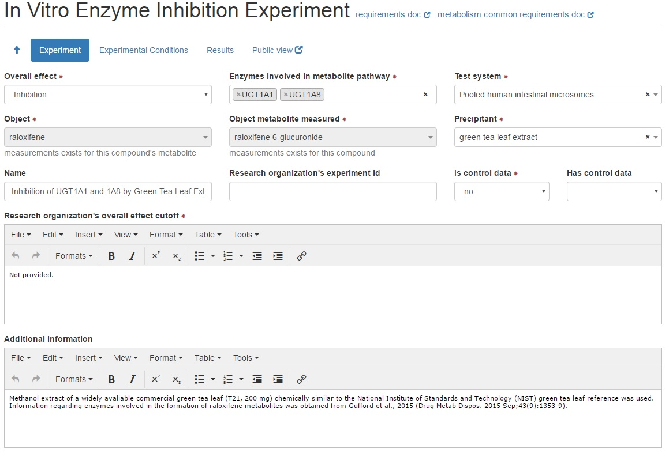

1. **Experimental Conditions**

|  |  |
| --- | --- |
| **Cell density** |  |
| **Protein concentration** |  |
| **Test system preparation**  **(check one if applicable)** | In-house preparation  Commercially available |
| **Test system lot number (manufacturer)** |  |
| **Incubation volume (µL units preferred)** |  |
| **Incubation Time (min units preferred)** |  |
| **Co-factors (check all that apply)** | MgCl2  NAD  NADH  NADPH  NADPH regenerating system  P450 reductase |
| **Co -substrates (check all that apply)** | UDPGA  PAPS  GSH |
| **Protein linearity tested?** | Yes  No |
| **Time linearity tested?** | Yes  No |
| **Precipitant concentrations tested (µM units preferred)** |  |

**Complete the following for time-dependent inhibition experiments:**

|  |  |
| --- | --- |
| **Precipitant pre-incubation volume (µL units preferred)** |  |
| **Precipitant pre-incubation time (min units preferred)** |  |
| **Precipitant pre-incubation conditions** | NADPH with precipitant  NADPH with no precipitant  no NADPH with precipitant  no NADPH with no precipitant |
| **Is this an IC50 shift experiment** | yes  no |
| **Select the experiment related to this** |  |
| **Secondary enzyme activity incubation volume**  **(µL units preferred)** |  |
| **Secondary enzyme activity incubation time(s)**  **(min units preferred)** |  |
| **Dilution factor from pre-incubation to secondary incubation** |  |

**Additional information regarding experimental conditions:**

|  |  |
| --- | --- |
| **Additional Information** |  |
| **Control conditions** |  |

**An example of data entered in the repository on the admin side:**

**3. Brief Summary of Results**

**For each experiment, please provide a brief summary of the results and conclusions**

|  |  |  |
| --- | --- | --- |
| **Experiment number and title** | **Inhibition type** | **Summary of results**  **(Provide values including units and types, see appendix II and III for details)** |
| 1. | Negligible inhibition  Inhibition  Competitive inhibition  Non-competitive inhibition  Un-competitive inhibition  Mixed inhibition  Time-dependent inhibition  reversible time-dependent inhibition  irreversible time-dependent inhibition  no time-dependent inhibition  Mechanism-based inhibition |  |
| 2. | Negligible inhibition  Inhibition  Competitive inhibition  Non-competitive inhibition  Un-competitive inhibition  Mixed inhibition  Time-dependent inhibition  reversible time-dependent inhibition  irreversible time-dependent inhibition  no time-dependent inhibition  Mechanism-based inhibition |  |
| 3. | Negligible inhibition  Inhibition  Competitive inhibition  Non-competitive inhibition  Un-competitive inhibition  Mixed inhibition  Time-dependent inhibition  reversible time-dependent inhibition  irreversible time-dependent inhibition  no time-dependent inhibition  Mechanism-based inhibition |  |

(Add more rows if needed)

|  |  |
| --- | --- |
| Additional Information (i.e, control results) |  |
| Conclusion |  |

**Attach relevant figures and tables of results when submitting this form.**

**Appendix I: Test Systems**

* **Cell system**
* Hepatocytes
* Human cryopreserved
* Human freshly isolated
* Transgenic animal
* Cell line
* HepG2 Cells
* HepaRG cells
* **Cell fraction**
* Human liver microsomes
* Pooled human liver microsomes
* Individual human liver microsomes
* Human intestinal microsomes
* Pooled human intestinal microsomes
* Individual human intestinal microsomes
* Cytosolic fraction
* Human liver
* Human intestine
* S9 fraction
* Human liver
* Human intestine
* **Recombinant expression system**
* Baculovirus-insect cells
* E.coli
* Yeast
* Not available

If “recombinant expression system” is used, make the selection for cytochrome b5 from the following:

**Cytochrome b5 (select one; required for recombinant expression system)**

* Yes
* Co-expressed
* Supplemented
* No
* Not available

**Appendix II: Enzyme Inhibition Parameters\***

* Percent Inhibition
* IC50
* Ki, total**
* Ki, unbound**
* Percent Inhibition pre-incubation
* Percent Inhibition co-incubation
* IC50 pre-incubation
* IC50 co-incubation
* IC50 fold-shift
* Kinact
* KI
* Kinact/KI

* Provide P-values where appropriate, provide value types (see appendix III)

**For Ki values, please provide:

* + Inhibition type:
    - Competitive
    - Non-competitive
    - Uncompetitive
    - Mixed
    - Time-dependent - reversible
    - Time-dependent - irreversible
    - Not time-dependent
    - Mechanism-based
  + Ki determination method:
    - Linear transformation – Dixon plot
    - Linear transformation - Eadie-Hofstee
    - Linear transformation – Lineweaver-Burk
    - Linear transformation – other
    - Nonlinear least-squares regression
    - Graphic read
    - Not available

**Appendix III: List of value types**

* Mean
* Mean ± SD
* Mean ± SEM
* Mean (range)
* Mean (CV%)
* Mean (CI)
* Median
* Median (CV%)
* Median (range)
* Median (CI)